173d AIRBORNE BRIGADE ASSOCIATION REUNION

Standard Operation Procedure

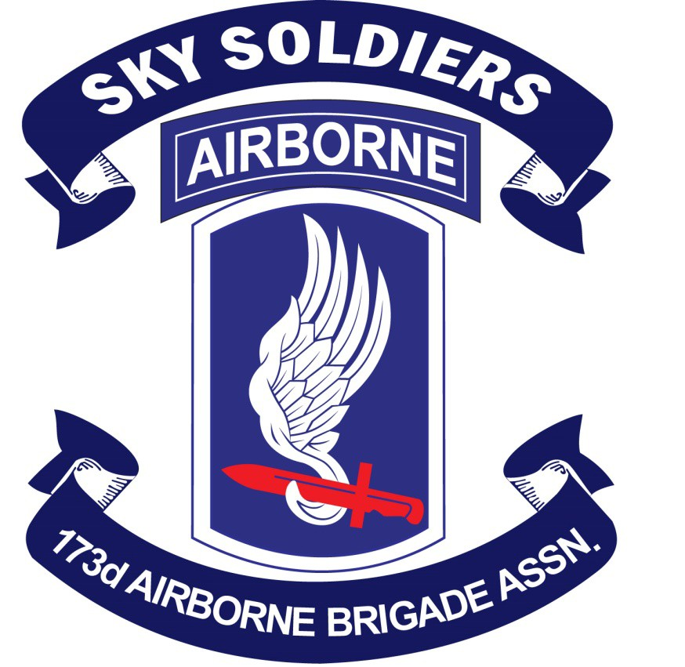

Approved by BOD: 18 January 2020

Wayne Bowers Joe Flesch

173d AIRBORNE BRIGADE ASSOCIATION REUNION SOP

TABLE OF CONTENTS

Page

Article I PURPOSE OF REUNION 2

Article II GENERAL 3

Article III REUNION BIDS 5

Article IV REUNION HOSTING REQUIREMENTS 7

Article V REUNION ADMINISTRATION 9

Article VI VENDORS/CONCESSIONS 10 Article VII RAFFLES 11
Article VIII EMERGENCY MEDICAL PLANNING CONSIDERATIONS 12

Article IX AFTERACTION REPORT 13

Article X SPECIAL GUESTS 14

Appendix I SAMPLE REUNION AGENDA 15

Appendix II BANQUET SEATING 16

Appendix III REUNION CHECK LIST 17

Appendix IV COMMENTS FOR CONSIDERATION 19

Appendix V SAMPLE REUNION AFTER ACTION REPORT 20

ARTICLE I PURPOSE OF REUNION

1. To afford 173d Airborne Brigade Association (ABA). Members, guests and Sky Soldier Gold Star families the opportunity to participate in an annual reunion sponsored and hosted by an active chapter and conducted for the 173d ABA in accordance with the Association bylaws.

2. To afford all Chapter Presidents or their designated representatives an opportunity to discuss both old and new business related to the Association with 173d ABA Board of Directors (BOD) and the Executive Committee (President, Vice President, Secretary, and Treasurer of the Association)..

3. To provide the general membership the opportunity to meet and interact with the entire 173d ABA Board of Directors.

4. To provide a venue for camaraderie and renewal of friendships for Association members, Gold Star families and guests.

ARTICLE II GENERAL
1. The purpose of this document is to establish requirements and/or guidelines for use by all chapters considering hosting the Association annual reunion.

2. The 173d ABA reunion shall be held normally between May 1 and August 15 each year. Exception must be approved by the Executive Committee of the Board of Directors.

3. Candidate Reunion Site/Venue Selection Process
a) Mid-Winter Conference two years in advance of target reunion: The 173d ABA reunion candidate host chapters and locations will identify their venue and anticipated activities to the BOD at the Mid-Winter Conference.
b) The chapter or chapters will then present a detailed outline of their proposal/proposals at the next General Membership Meeting (two years in advance of the target reunion).
c) At the reunion two years prior to the target reunion the candidate chapter/chapters will make a formal presentation of their detailed reunion plan/plans to the General Membership. A majority vote of the membership present will determine the host chapter for that reunion. If there is no candidate agreed upon by the membership the Association will either host the reunion itself or work with a chapter to host.

4. The 173d ABA reunion should not be held in the same location two years consecutively.

5. Registration fees paid for the 173d ABA annual reunion will include the hospitality room, banquet, and registration gift(s) ONLY. The host chapter will establish a reasonable registration fee not to exceed $173. This limit will be revisited by the BOD every five years. Side trips or tours will require additional fees for each event and are not considered registration fees for cost sharing between the host chapter and the 173d ABA (See 173d ABA By-Laws Article VI Annual Reunion, Section 2. B. registration profit is shared 67% to the host chapter and 33% to the 173d ABA). Profit and/or loss associated with reunion tours/events sponsored by the host chapter are either a gain or loss for that chapter. Note: 173d ABA Bylaws Article VI B. states “Within (90) days after completion of an Annual Reunion, the reunion receipts and expenditures pertaining to the Reunion shall be forwarded to the Treasurer. If the report shows expenditures exceeded the Attendee Registration Fees of the Annual Reunion, the Host Chapter may petition the Board of Directors to pay the loss or part thereof.”

6. Eligibility to attend the 173d ABA annual reunion is limited to current or past Association members of the 173d Airborne Brigade/173d Airborne Combat Team, active duty Sky Soldiers, Sky Soldier Gold Star family members their guests and special guest invited by the host chapter or the Association. While difficult for a chapter to verify unequivocally membership status the host chapter should make every reasonable effort to screen attendees.

7. The 173d ABA annual reunion is an opportunity for the hosting chapter and the Association to generate needed revenue. However, by keeping registration cost down it will enable more members to attend.

ARTICLE III HOSTING BIDS

1. Chapters bidding to host the 173d ABA reunion must meet the following requirements.

a. Have permanent chapter status in accordance of the 173d Airborne
Brigade Association bylaws.

b. The bidding chapters should have sufficient funds on hand to defray initial cost and expense of hosting the reunion. (Suggested minimum funds of $2,500). These funds will be reimbursed by the Association once registration fees begin to accumulate.

c. Prepare a brief but explicit bid in writing to be presented to the membership and Association Board of Directors at the reunion in progress. It is recommended that bids be submitted 90 days prior to the upcoming reunion in order that the Association Officers may determine if the bid meets all requirements.

d. A cost analysis (budget) must be submitted with the reunion bid and should include all expected expenditures. It is recommended that a minimum figure of 600 attendees be used when calculating expenditures. Registration fees should be arrived at by dividing expenditures plus desired profit by 600.

2. The chapter selected to host the annual reunion will be informed at the reunion two years prior to. Selection will be determined by general membership vote at the reunion in progress. The decision will be confirmed in writing to the selected chapter by the association president.

3. The announcement of the selected chapter will be made at the general membership meeting at the reunion in progress.

4. Any chapter desiring to host an annual reunion may assist their efforts with a display booth containing, but not limited to a copy of the written bid, literature, pictures and videos. The display of presentation will be in accordance and coordinated with the host chapter of the reunion in progress.

5. Profits derived from the annual reunion will be split 67/33 with 67% going to the host chapter and 33% going to the Association.

6. Disbursements of the split will be made no later than ninety (90) days after completion of the annual reunion.

7. The hosting chapter will summit in writing an after-action report (summary) to the Association, no later than ninety (90) days after completion of the annual reunion.
8. The hosting chapter may want to consider using a concierge service to assist in their planning and coordination with hotels and transportation services. Some past host chapters have used such a service to negotiate contracts and can provide you contact information for concierge services.

ARTICLE IV

REUNION HOST REQUIREMENTS

1. The host chapter will establish or appoint a reunion committee chairman, a reunion treasurer and other committee members needed to ensure a successful reunion. It is recommended to have eight to fifteen committee members. Representatives of the Association Executive Committee of the Association Board of Directors should be included on the chapter’s Reunion Committee.

2. The reunion Chairman and Treasurer will be provided a bank routing number by the Association. This is done in accordance with Association bylaws so all incoming funds are controlled by the Association. The Association will provide a bank debit card to the hosting chapter to be used for reunion expenditures

3. The reunion chairman is responsible for liaison coordination to the Association Headquarters as to the extent and update of activities planned and attendees registered.

4. Upon request the reunion chairman may use the assistance of the Association and their assets, such as the SKY SOLDIER magazine and 173d ABA website.

5. The 173d ABA reunion will be a three to five-day event, not including departure day.

6. The host chapter will submit in writing a quarterly report to be published in the SKY SOLDIER magazine concerning the upcoming reunion.

7. The host chapter will provide an agenda broken down into days and time of daily reunion events. (See Appendix I & II for examples)

8. The host chapter will have a registration packet for each reunion attendee upon arrival at the reunion. The packet should contain nametag, registration gift(s), (if covered by registration fee) beverage tickets, (beverage tickets are not necessary if registration fee provides for free hospitality room) site map, schedule of events and any other items thought to be necessary by the host chapter.

9. The host chapter registration staff should be organized and have enough members to expedite the flow of arriving attendees. It is recommended that all packets be in alphabetical order in separated boxes with several booths being utilized for quick processing. Procedures for walk-ins should be in place. Procedures for after hour arrivals should be prominently displayed in the registration area. It is recommended that the registration staff consist of chapter members (and spouses) with knowledge of the
reunion in order to answer attendee’s questions. Outside personnel such as
Chamber of Commerce should not be used in key positions.

10.The host chapter will provide a bulletin board to be prominently located in the registration area. The board’s main function will be to notify the attendees of any schedule/agenda changes. Personal messages may be posted on a space available basis.

11.The host chapter is responsible for providing the Association with a room suitable for conducting meetings. The room should accommodate up to thirty persons for use by the Board of Directors and provide secure storage of Association property. Coordination of the use and security of this room will be coordinated through the Association Secretary and the host chapter. The host chapter will coordinate with the host facility for needed audiovisual support.

12.The host chapter is responsible for providing a room large enough to facilitate a general membership meeting. (four to five hundred members)

13.The host chapter is responsible for providing a venue large enough to host a banquet. The host chapter will select a banquet meal. The National Association will be responsible for developing the banquet agenda and conducting the banquet. The host chapter will be the Association point of contact with the hotel regarding audio visual support and arrangements of the head table. In coordination with the Executive Committee of the BOD the host chapter will ensure the retention of a photographer to record the banquet. The Association will conduct the banquet and is responsible for providing the master of ceremonies, color guard and guest speaker.

ARTICLE V REUNION ADMINSTRATION

1.) A check list to ensure against omission of details and maintain continuity should be the first priority of the host chapter (see Appendix III for a suggested checklist)

2.) A list of facilities, activities, points of interest and various modes and methods of transportation.

3.) Upon receipt of registration monies, a letter of acknowledgement or email will be sent to the member stating that his registration fees have been received and a reunion packet will be provided to each attendee on the day of arrival at Reunion check-in.

4.) Name tags should be durable, readable at a distance, in good taste and if possible contain the reunion theme.

5.) As stated in Article IV, the Association will conduct the Banquet, to include the agenda, providing the master of ceremonies, Color Guard and guest speaker(s).

6.) A reasonable date for refund cutoff should be established and posted on the reunion website and the registration application. The reunion chairman may waive the cutoff date based on extreme circumstance.

ARTICLE VI VENDORS VENDORS/CONCESSIONS

1. The following guidelines are established pertaining to vendors attending the 173d ABA reunions.

a. The host chapter should require each vendor to provide certain information to them prior to scheduled reunion date. Minimum requirements are:

i. What products will they be selling?

ii. What are their prices?

iii. Have they operated a booth at a prior 173d ABA reunion?

iv. Are the items in good taste and not inflammatory against the
Association or the United States Government.

b. The cost of vendor tables is determined by the host chapter. c. Vendor space availability is determined by the host chapter.
d. Although security may be provided by the hotel, the responsibility for security of vendor items falls to the individual vendor.

2. Non 173d vendors should be scrutinized.
3. All vendors will be furnished guidelines on setting up their tables/booths
based on host hotel criteria. Vendors will responsible for procuring any electrical access beyond the standard electrical access negotiated by host chapter with the hotel. The vendor is responsible for coordinating any pre/post reunion storage of their wares/equipment with the hotel. Non-compliance of these guidelines will result in forfeiture of both space and payments.
4. Vendor room should be large enough to accommodate all vendor tables. It should also be securable and chapter should utilize a single entry door for attendees.

ARTICLE VII RAFFLES
1. The drawing for raffles sponsored by the Association should be conducted at reunion banquet. The Association is responsible for the conduct of their raffles. Tickets with instructions are normally mailed to each member three to four months prior to the reunion. Members need not be present to win.

2. Chapters to include the Host Chapter may conduct their own raffle/drawing with certain restraints. Sales can only take place at a vendor table, hospitality room or Chapter sales table. Under no circumstances will sales be conducted during meetings, or briefings, i.e., General Membership meetings, etc.

3. All Chapter raffles will be cleared through Hosting Chapter.

ARTICLE VIII

EMERGENCY MEDICAL PLANNING CONSIDERATIONS

The Following basic medical considerations should be planned.

1. As our Association grows older, so does the membership as a whole. A large number of the more mature members have various health problems.

2. The reunion is planned to have fun and enjoy old friendships with talk of our youthful times. In all the excitement, and with alcohol and the heat of the weather, the stage is set for potential tragedy.

3. The following considerations are recommended.

a. Reunion registration forms should have space for attendees to specify health needs.

b. Establish with the host hotel the need for assistance. All well- established hotels have medical plans and the phone numbers of local EMS. The plans should be visibly posted and provided in the registration packet.

c. At the beginning of the reunion, survey personnel attending for Doctors, PA’s and Medics who in case of emergency could be of assistance.

d. All venues must be handicap accessible. Check the availability of both electric and non-electric wheelchairs for those attendees that have mobility problems.

ARTICLE IX

AFTER ACTION REPORT

1. An after-action report must be submitted to the Association within
90 days of completion of the reunion. The after-action report should
be as detailed as possible and include a profit and loss statement.

2. Host Chapters of upcoming reunions may apply in writing to the Association for a copy of any past after action reports to be utilized in reunion planning.

3. A reunion checklist is outlined in Appendix III. It is an invaluable aid in the preparation of an after action report.

4. Appendix IV contains a sample copy of an after-action report.

ARTICLE X SPECIAL GUEST
There are two categories of special guests that will/may be invited to our reunion: Guest speaker (and guest(s) of honor.

1. The utilization of a guest speaker is optional and at the discretion of the Association. The Host Chapter will pay for one nights lodging and the banquet meal. All other expense will be covered by the Association.

2. Medal of Honor recipients, Commanding Officer and Command Sergeant Major of the 173d Airborne Brigade may be invited at the discretion of the Host Chapter. One nights lodging and the banquet meal will be paid for by the Hosting Chapter.

3. Gold Star family members and Active Duty soldiers of the 173d Airborne Brigade may be given a reduced rate for attending any/all reunion functions at the discretion of the Host Chapter.

The invitation to special guest should be held to a minimum. The payment of expense for special guests are significant and will raise the cost of membership registration which may preclude some members from attending. Host Chapters should keep in mind persons attending from other chapters have both travel and hotel expense to deal with.

APPENDIX I
SAMPLE REUNION AGENDA
Day 1 – Wednesday 0800-1600 Early Bird Registration
1000-2200 Hospitality Room
1000-1700 Vendor Room
Day 2 – Thursday 0800-1800 Registration
0900-1100 Board of Directors Meeting
0900-2200 Hospitality Room
1000-1700 Vendor Room
Day 3 – Friday 0730-0900 Breakfast
0900-2200 Hospitality Room
0900-1200 Event 1 (Include Transport)
1000-1700 Vendor Room
1200-1330 Reunion Picnic
1400-1600 Event 2 (Include Transport)
1700-2200 Subunit/Chapter Event Time
(as planned & funded by them)
Day 4 – Saturday 0730-0900 Breakfast
0900-1300 Hospitality Room
0930-1130 Event 3 (Include Transport
1000-1600 Vendor Room
1200-1330 Ladies Lunch
1200-1330 Gold Star Lunch
1400-1530 General Membership Meeting
1530-1730 Hospitality Room
1800-2200 173d ABA Banquet
Day 5 – Sunday 0730-0900 Breakfast
1000-1100 Memorial Service
The above is only a guide line. A final agenda should be submitted to National for approval. Any changes made after publication should be prominently displayed at reunion

APPENDIX II BANQUET SEATING
Although the Banquet will be conducted by the Association the following is
a suggested guideline.

1. Special interest should be given to the banquet and treat it as a gala affair. Dress should be formal/semi-formal.

2. Seating at head table should be limited to the Host Chapter President and Lady, Guest Speaker and Lady, Association President and Lady and Reunion Chairman and Lady.

3. Association Officers, Ladies and MOH recipients, Brigade Commander, Brigade Sergeant Major, other VIP’s and their Ladies should be at adjacent table(s).
4. Host chapter Reunion staff should get reserved tables near the head table.

5. Color Guard sourced by the Association.

APPENDIX III REUNION CHECK LIST
1. ACCOMMODATIONS: Contact the hotel convention manager to establish a
mutual agreement and secure a written confirmation regarding the
following.

a. Total number of guest rooms required. b. Official dates of the reunion.
c. Number arriving prior to official opening. d. Peak day/evening.
e. Date when members will start checking in/out.
f. Date majority of group will depart.
g. How will reservations be handled.

2. REGISTRATION PACKETS: Provided by host chapter and registration committee to be given out at reunion check-in.

3. HOTEL FUNCTIONS ROOMS: Provide hotel staff a tentative day-by-day, time program and room requirements with estimate attendance.

4. MEETING ROOMS & REQUIRMENTS:

a. Daily needs, time and estimated attendance for each room. b. Room assignment.
c. How to set up chairs and tables.
d. Speaker’s table, for how many, floor level or raised stage.
e. Reading stand, light and gavel.
f. PA system, projector.
g. Decorations, flags, banners or displays. h. Drinking water, coffee, etc.
i. HVAC controls
j. Writing boards, easels, bulletin boards, etc.

5. FOOD FUNCTION:

a. Arrange with hotel staff and caterer in advance . b. Meals time and location, attendance.
c. Arrange for wine and water glasses to be on table for toasting.
d. Menu and price, Arrange in advance of reunion with written
confirmation.
e. Banquet seating, head table(s), podium, microphones, flags, etc.
f. Cocktail hour, bartenders, cash bar, etc. g. Entertainment requiremnets.*

6. REGISTRATION:

a. Prior to reunion arrange with hotel staff.
b. Number of stations and desk needed, packets prepared
alphabetically.
c. Personnel needed, dates and times.
d. Equipment needed, pens, pencils, paper, computers, etc.
e. Procedures for accepting walk-in payment, cash box, credit card
machine.
f. Membership forms available.
g. ID badges for reunion committee members.
h. Bulletin boards for posting changes, directions, general info, etc.

7. MISCELLANEOUS:

a. Flags with stands, banners, decoration, etc. b. Photographer
c. Signs, programs, menus
d. Location of restaurants, beauty shops/hairdressers, etc.

*Few people stay for entertainment or band (consider cost vs. benefit)

APPENDIX IV COMMENTS FOR CONSIDERATION
The following are comments made by members after previous reunions.
These are provided for consideration and should not be construed as
requirements placed on host chapters.

1. No assigned seating, in general, people decide whom they want to sit with (those they only see once a year) that means not necessarily sitting with their chapter.

2. Coordinate with a photographer to take individual couple or group pictures throughout the reunion. (not at hosting chapter expense.)

3. If a fee is included for the hospitality room as part of the reunion registration fee, there should be no charges for drink, snacks, etc. We would much rather pay a higher registration fee and have free drinks and snacks than pay $5.00 per drink.

4. Coffee and donuts provided each morning before hospitality room opens.

5. When meetings are in progress provide another room for hospitality.

APPENDIX V

SAMPLE REUNION AFTER ACTION REPORT

SUBJECT: After Action Report, Reunion XXXX (location name or city date) TO:
173d AIRBORNE ASSOCIATION
Attn: President

FROM: Chapter XX

1. Theme

2. Accomplishments

a. Date reunion committee was formed, name of Chairman and members.
b. Committee function and job assignments, registration sales, website, guest speaker, advertisement, entertainment, coordination with National, transportation, hotel accommodations, preparation of registration packets, name tags, vendors, tour information, airport pick-ups, golf outing,
c. Day-by-day recap of reunion activities.

3. LESSONS LEARNED AND PROBLEM AREAS:

a. b. c.

4. RECOMMENDATIONS:

5. FINANCIAL STATEMENTS:
a. Beginning Balance of checking account
b. Deposits:
i. Registration Fees ii. Vendor Tables iii. Coin Sales iv. Tour Sales v. Other Income _

Disbursements (by check #, amount , who/why)
Check # amount who/why
Check # amount who/why
Check # amount who/why Check # amount who/why Check # amount who/why Check # amount who/why

