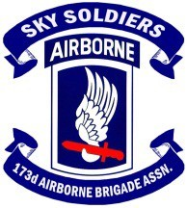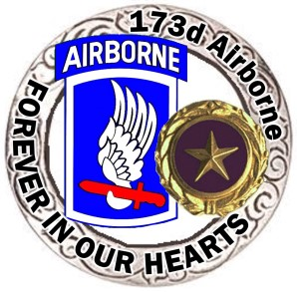
The 173D Airborne Association Official Gold Star Progam

MISSION STATEMENT
The 173^{d} Airborne Assn. Gold Star Program is a private nonprofit C 19
Military Organization created to provide Honor, Remembrance, Emotional, Peer, and Resource Support for 173^{d} Airborne Gold Star Families.
We will host a gathering of Gold Star Family Members at every National Association Reunion, to ensure the sacrifices made will NEVER BE FORGOTTEN.
To provide increased Public Awareness of what the Gold Star and Next of Kin Pin are, and the sacrifice required to wear one.

History, Reunion 2023, Reconnecting, Planning for 2023 and beyond
The initiative to support the Association Gold Star Family members was brought forth through the vision of the late General John R. Deane, Jr. and Col. Robert Sigholtz and was implement by Judy C. Campbell (Gold Star Sister of Sp/4 Keith Allen Campbell - DSC, BSM ‘v’, PH - Combat Medic – KIA Vietnam 02/08/1967), who became the first Chairperson of the Associations Gold Star Committee. The program was taken over and run by the leadership of the 173d Airborne Brigade Association for a few years. Debora Yashinski with the support of her husband James (Gold Star Parents of Sgt. Michael Emerson Yashinski – BSM - KIA Iraq 12/24/2003) came on board as Chair took it to the next level by researching and building the database Gold Star Family Members. That same database was used by the 173d Airborne Brigade Memorial Foundation to reach out to the Gold Star Family members as that project developed and was completed. Under Eric Hitchcock’s leadership of the then called 173d Airborne Brigade Association Foundation, Doris Brazzale-Hovis was invited to Chair the Gold Star Family program. She has been its organizer and champion during the past 6 years with the support of her two talented and dedicated daughters. Overall the program has been in existence and active nearing 20 years.
Judy’s, Deborah’s and Doris’s dedication, personal touch and sensitivity to the needs of each Gold Star Family member has continually improved the quality of the event at the reunions and facilitated a mutual support relationship among those attending that extended beyond the time at the reunion. As new Gold Star Family members have joined us at the reunions, where the Association has hosted them at exclusive luncheons or dinners, so have Sky Soldiers come forth who had served with their KIA loved one, and have joined the event. Each reunion event being memorable for all participants and a significant contributor to the healing of both the Gold Star Family members and the Sky Soldiers who served with their loved one plus those supporting the events.
At this time a monumental task calls on us to rally together in the effort to reconnect with all Gold Star Family members in the existing database, and update it to reflect the current status of those listed there and add those who should be in that list. That requires 173d Airborne Brigade Association and its Chapters and members, to reach out and locate those Gold Star Family members.
The 173d Airborne Brigade Association 2023 reunion registration has begun and we encourage all Association Chapters and members to reach out to the Gold Star Family members in their area of operation and invite them to attend.
The 173d Airborne Brigade Association offers a lifetime honorary membership for the Association Gold Star Family members (parents, siblings, children and grandchildren) upon the Associations Gold Star Programs confirmation.
We invite Gold Star Sky Soldiers and their Gold Star spouses and their
Gold Star children, who lost a loved one serving with other units of the U.S. Armed Forces, to join the Sky Soldier Gold Star Family and attend its events.
Let us not leave any Sky Soldier Gold Star Family member to wonder if anyone cares about their loss and pain. Join the team to let them know that THE SACRIFICE OF THEIR LOVED ONE WILL NEVER BE FOGOTTEN AND NEITHER WILL THEY. To volunteer please contact
Eric Hitchcock at eric@blastincorporated.com or by phone 713-545-3974

CONTACT INFORMATION TO REACH OUT TO OUR GOLD STAR PROGRAM CO-CHAIRWOMEN.

JUDY C. CAMPBELL hersis1@gmail.com
DORIS BRAZZALE-HOVIS bradoris@yahoo.com

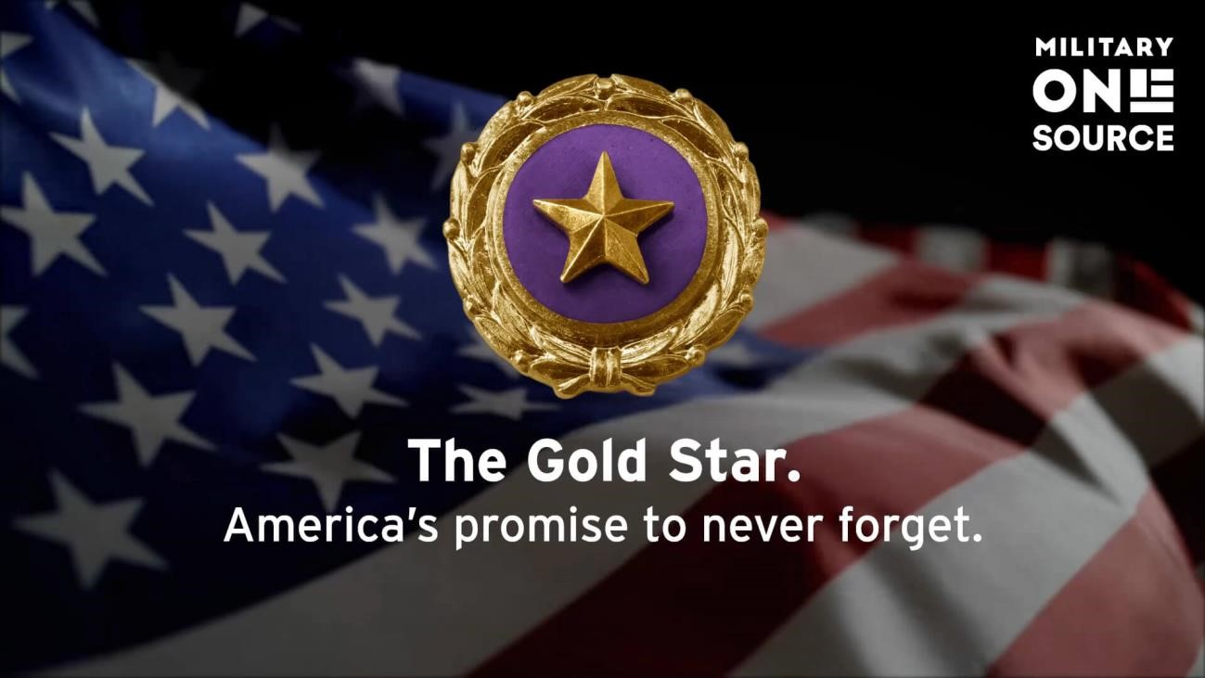

To donate
–

Make checks out to:

“The 173D Airborne Association”
Send to: Sky Soldier Tim Austin
13148 Chinkapin Oak Pl
Choclaw, Ok 773020-2006
• You must have Gold Star Program written in the memo section on the check!

(NEED ELECTRONIC DONATION SET UP)

GOLD STAR FAMLY LUNCHEON AT SCOTTSDALE REUNION 2022

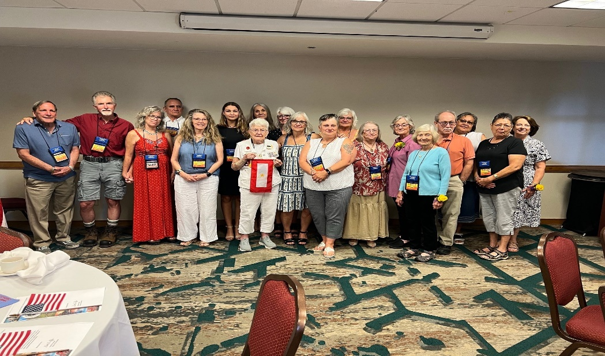
Gold Star Family members that attended The Gold Star Luncheon at the 2022 Scottsdale Reunion. From left to right above are Tom Diamond (Guest), Wayne and Barbara Forkum, Joe Marquez, Pam Pikens, Kelly Hovis, Mrs. Ruth Forkum, Doris Hovis Debra Lopata, Shannon Mitchell, Maureen Kinest, Pam Kunkel, Mary Day, Jacinta Williams, Lavina Livingston, Mark Busenlehner, Rose Hale, Darlene Wewenes, Judy Campbell

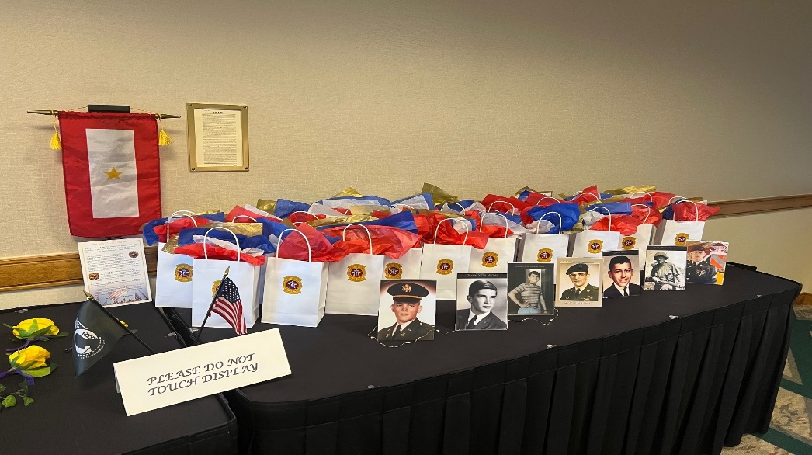
Gift Bags for Gold Star Family attendees’ w/ Pictures of their Honored Family Member.

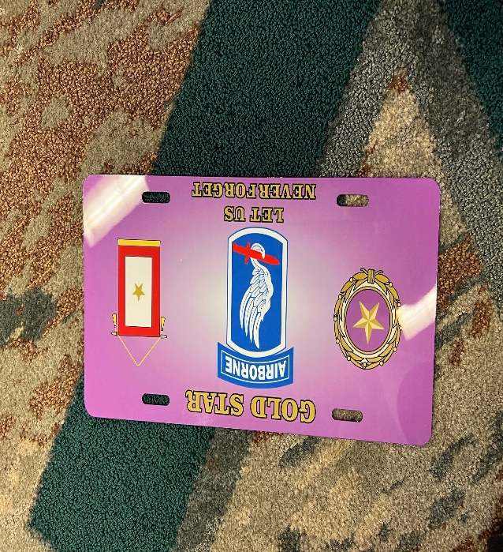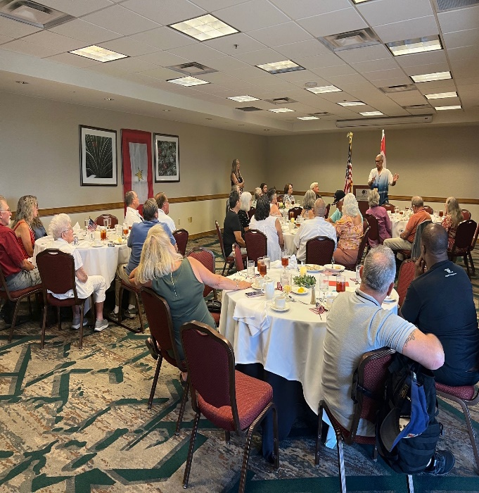
Gold Star plate given to attendees.
Newley Elected Association President Wambi Cook addressing our Gold Stars & invited Guests.

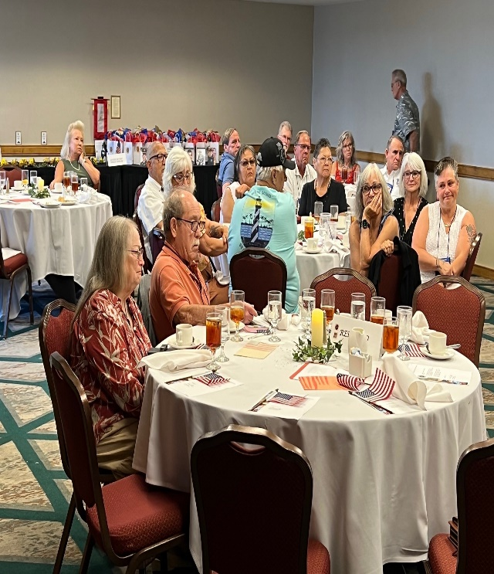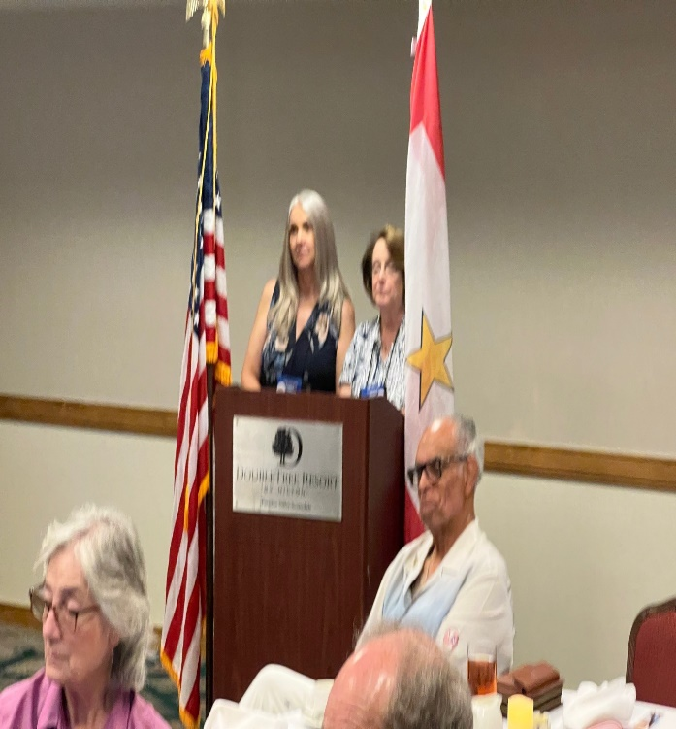
When everyone was Sharing about their Loved One we all listened attentively, Very Emotional, But Great experience!
Co- Chairs Doris Brazzale-Hovis and Judy C. Campbell Thanking the group.

GOLD STAR LAPEL BUTTON AND NEXT OF KIN DECEASED LAPEL BUTTON

Much confusion surrounds the significance of the lapel pins given to surviving family GOLD STAR LAPEL BUTTON AND NEXT OF KIN DECEASED LAPEL BUTTON
Much confusion surrounds the significance of the lapel pins given to surviving family members shortly after the interment of their loved one who died while serving honorably in the Armed Forces. Although there may be differences in presentation between the branches of service, there is only one law that governs the procurement, awarding, and wearing of the pins. Each of the two lapel pins have been authorized by Act of Congress. The legal and military distinctions between the two are based on the place, time, and circumstances of the death, as well as the survivor’s relationship to the deceased. For either pin, eligible family members include: widow, widower, mother, father, stepparent, parent through adoption, foster parent in loco parentis, son, daughter, stepchild , child by adoption, brother, sister, half brother, and half sister. No other family members are legally eligible to receive the pin.
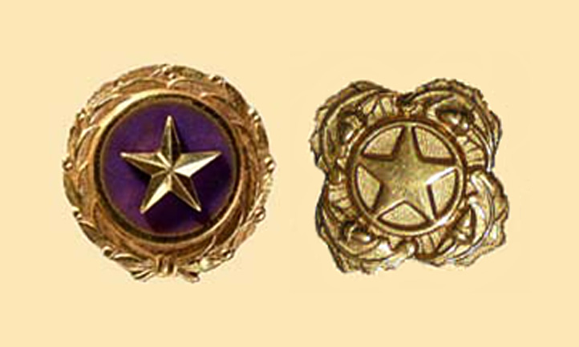

GOLD STAR LAPEL BUTTON
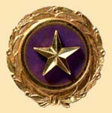The Gold Star Lapel Button was designed and created in 1947 for family members of those who died in combat. It is a gold star on a field of purple surrounded by laurel leaves. Gold Star Lapel Buttons are awarded to surviving family members of service members who have been killed in the specific conflicts listed in the "Information" section on the back of DD Form 3. The award authority is retroactive to World War I, and includes most subsequent conflicts. The law stipulates that only one button is furnished to each recipient, but a request for replacement of the Gold Star Lapel Button (lost, destroyed, or unserviceable) can be submitted on DD Form 3 (Application for Gold Star Lapel Button) to NPRC, 1 Archives Drive, St. Louis, MO 63138. If your loved one was killed during the time period of one of these conflicts, but not in the official area of the conflict you would receive the Next of Kin Deceased Personnel Lapel Button.

NEXT OF KIN DECEASED PERSONNEL LAPEL BUTTON
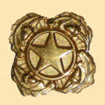The Next of Kin Deceased Personnel Lapel Button was approved in 1973 for the primary next of kin of armed services members who lose their lives while serving on active duty or while assigned in an Army Reserve or Army National Guard unit in a drill status. It is a gold star on a gold background surrounded by four oak sprigs. The pin is authorized for issue retroactive to March 29, 1973. If you are a relative listed above and your loved one died while on active duty, but under circumstances that do not qualify you for the Gold Star Lapel Pin, you are entitled to the Next of Kin Deceased Personnel Lapel Button. The next of kin may request issue of the button by writing to the NPRC, 1 Archives Drive, St. Louis, MO 63138. Furnish the name, grade, SSN, and date of death of the deceased soldier. The names and relationships of the next of kin must also be provided.

stepsiblings now inclUDED in gold star lapel button program
On Sept. 25, 2020, the Gold Star Lapel Button Program was officially expanded to include stepsiblings.
Military families bear a tremendous burden when their loved ones die while defending their country’s liberty. Nothing can erase the pain and suffering these families feel, but one way the nation shows its appreciation of a service member’s sacrifice is by honoring eligible survivors with a Gold Star Lapel Button.

Resources abound to assist gold star surviors
With the Gold Star Lapel Button now being available to stepsiblings, they can join their family members in displaying this important symbol of sacrifice. But while these families have lost their service member, they can take comfort in knowing that they have not lost the support of their military family, which continues to be there for them during their time of greatest need.
To learn more about the resources and benefits available to gold star survivors, download A Survivor’s Guide to Benefits: Taking Care of Our Families, or see an overview of what’s available at Gold Star & Surviving Family Members – Benefits.
A new Survivor Family Member Inquiry Form is also available for survivors to submit their questions and/or concerns.
More comprehensive information about various benefits for gold star survivors can be found in the Gold Star & Surviving Family Members section of Military OneSource.

Gold Star Mother’s and Family’s Day
The origin of what would become Gold Star Mother’s and Family’s Day started with a simple accessory: a black armband with a gilt star.
During World War I, family members would wear these armbands to represent a loved one who had died in the war. The stars would later find their way to being displayed on banners that were hung in windows or front doors. Banners with blue stars were hung to represent immediate family members who were serving. Some would have one star; others would have two or three. The stars symbolized the people who were supposed to be home but were missing from the dinner table. If a family member died during their service, the blue star would be replaced with a gold one.
Grace Darling Seibold was one of these mothers with a gold star in her window. Her son, 23-year-old George Vaughn Seibold, volunteered to be an aviator and was sent to England in 1917 as part of the British Royal Flying Corps. Grace and George had regularly exchanged letters until she suddenly stopped hearing from him. Nevertheless, she held out hope. In 1918, she received his personal belongings and confirmation of his death. George’s body was never identified.
Grace then used her time and grief to reach out to other mothers trying to cope with similar losses. Twenty-five of these women banded together in 1928 to create American Gold Star Mothers, Inc. — a group that still exists today — to honor their children, heal together, and support veterans and the nation. In 1936, Congress designated the last Sunday in September as Gold Star Mother’s Day (now known as Gold Star Mother’s and Family’s Day).
Following the end of World War II, Congress designated the Gold Star Lapel Pin. The pin was modeled after the banners and features a gold star with a purple background surrounded by laurel leaves. According to law, the United States military must present the lapel pin to the immediate family member of the deceased. If you see someone wearing this pin, know that they lost someone close to them who served the country heroically.
Gold Star mothers and families suffer a loss too terrible for most people to imagine. Nothing can erase that tragedy from their lives. Today, we honor their sacrifices. This Sunday, September 25, Arlington National Cemetery is honored to host Gold Star Mothers and Families to commemorate the holiday at the Tomb of the Unknown Soldier.

